Add Headings (Format > Paragraph styles) and they will appear in your table of contents.

Dermatology Case Studies
Derma1: Arthropod Bites (Insect Bite)
PRIMARY CARE VISIT REPORT
A 26-year-old male with no past medical history presented with a rash on bilateral arms and wrists. The patient had woken up with the skin lesions 1 day prior. They were very itchy. They had gotten progressively worse since they appeared and seemed to become more symptomatic after he showered. The patient applied topical Benadryl cream which did not help.

PHYSICAL EXAMINATION
Vitals were normal. On exam, there were multiple scattered erythematous papules with some excoriations on bilateral arms. There were no lesions in the web spaces of his fingers and no burrows. His right arm had an area of linear lesions, otherwise the lesions were diffusely scattered. The lesions seemed to be bites; however, Primary Care was unsure of the source.The patient was treated for scabies with permethrin cream, and referred to dermatology in case the lesions did not clear up.

Differential Dx
• Arthropod bites
• Scabies
• Urticaria
• Folliculitis

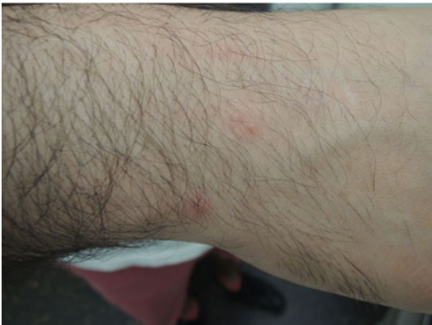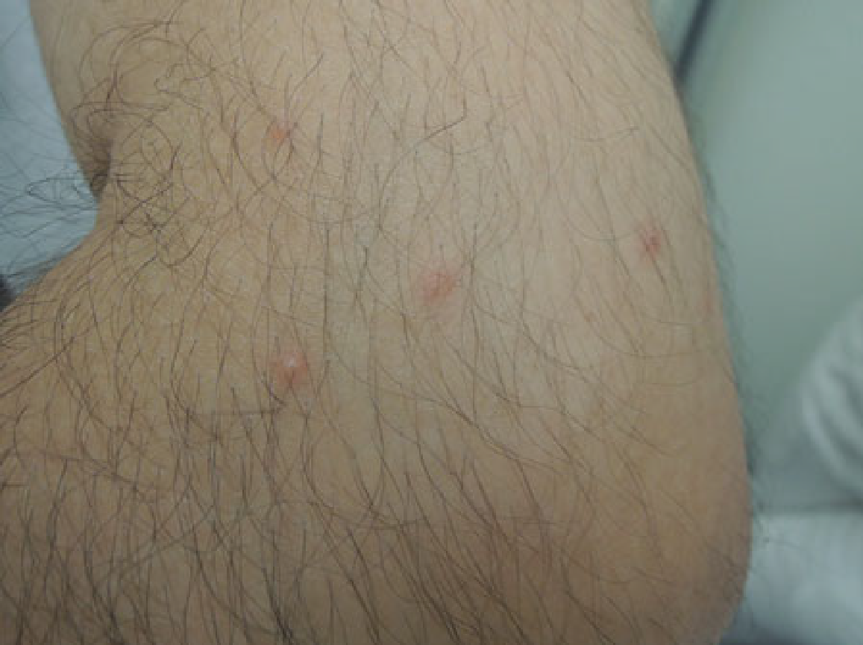

Citation: Reich D, Psomadakis CE, Buka B. Top 50 Dermatology Case Studies for Primary Care Primary Care Primary Care.

Derma2: Tinea Pedis
HISTORY
A 37-year-old female with no past medical history presented with left foot pain which started acutely 2 days prior. At the visit, the pain was so severe she had trouble putting her shoe on. The pain was in the toe webbing between her left fourth and fifth toes. She had applied over-the-counter Lotrimin for athlete’s foot but it did not help. She also had two thick yellow toenails on her left fourth and fifth toes, which had been like that for years.
PHYSICAL EXAMINATION
Vitals were normal. On exam, there was a 5× 5 mm yellow macular blister with some surrounding erythema in the toe webbing between the left 4th and 5th toes; there was trace edema and mild erythema on her 5th toe; there was some erythema on the dorsal aspect of the base of the 4th/5th toe webbing. The 4th and 5th toenails of the left foot were yellow, thickened, and ridged.
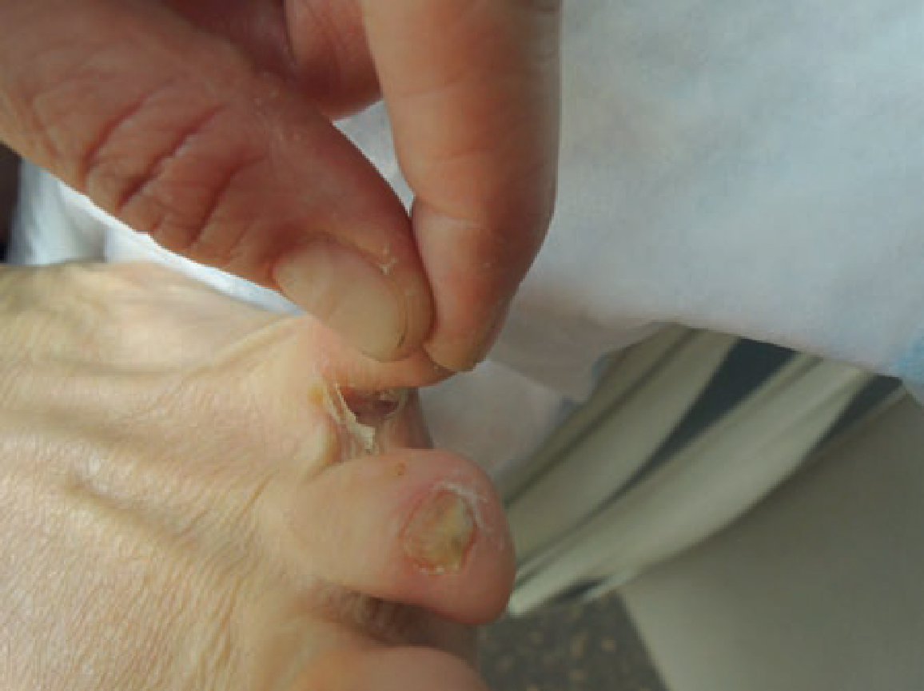
Citation: Reich D, Psomadakis CE, Buka B. Top 50 Dermatology Case Studies for Primary Care Primary Care Primary Care.

Derma3:Cellulitis
HISTORY
A 24-year-old male with past medical history of staphylococcal and streptococcal skin infections and abscesses presented with an open lesion on his right posterior ankle accompanied by right leg erythema and edema. Five days prior to this visit, his right foot and leg started swelling and becoming red, and the site of the prior blister opened up. The day prior to this visit, a “black spot” appeared adjacent to the open lesion, which then also “broke open,” forming a large wound. He denied fever or chills and felt otherwise well. The patient reported that the area had been much more painful 2–3 days prior to this visit, at which time he could not put on a shoe due to the pain and swelling. The pain had improved by the time of visit.

PHYSICAL EXAMINATION

Vitals were normal. On exam, there was a 3.5 cm × 2 cm weeping ulcer on the lateral outer area of his right heel, with surrounding blanchable erythema on his foot and ankle that extended to the mid lower leg. There was 1+ edema on the right lower leg.
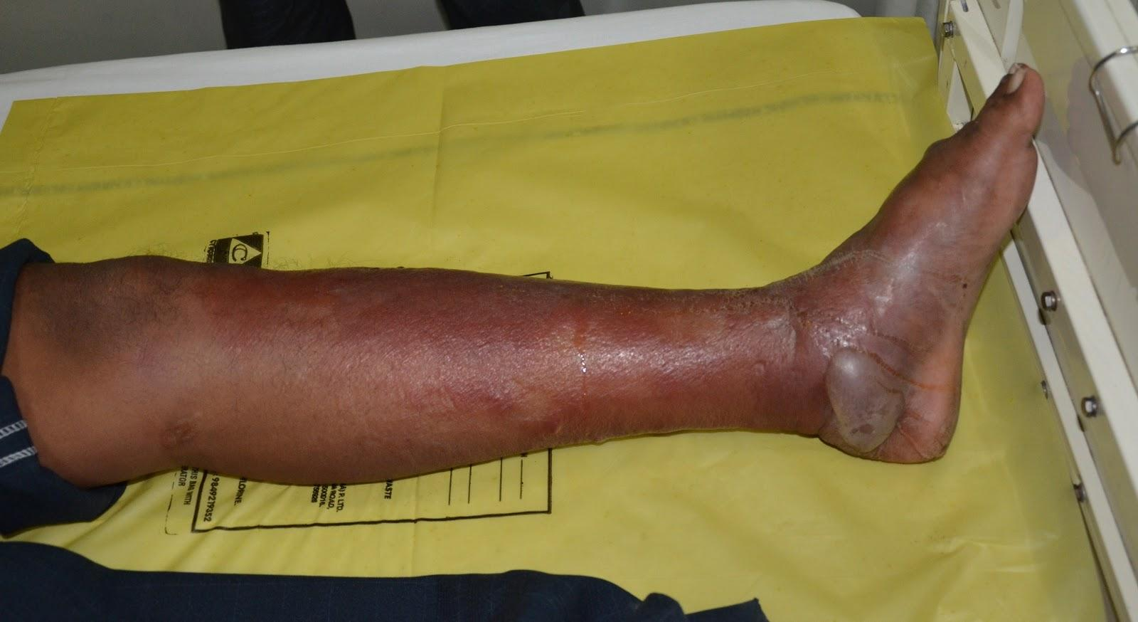

Citation: Reich D, Psomadakis CE, Buka B. Top 50 Dermatology Case Studies for Primary Care Primary Care Primary Care.

Derma4: Breast Cancer
HISTORY
A 37-year-old female with past medical history of Vitamin D deficiency presented for an annual physical exam. She was concerned about a lump in her right breast that she had first noticed about 2 months prior. She noted that the skin overlying the lump had become discolored over the past 2 months, it was sometimes tender, and the lump had been growing in size. She had no family history of breast cancer. At age 16, she had a benign breast lump in the same breast. The lump was removed at that time and an implant was placed in her right breast. The implant was then removed 2 years later, at age 18. Her last mammogram 2 years prior was normal.

PHYSICAL EXAMINATION

Vitals were normal. On exam, around 10:00 of her lateral right breast, there was a 7cm× 7 cm indurated area, with a central 5cm× 3 cm area of discoloration. The lesion was purple-colored and erythematous, with central puckering.

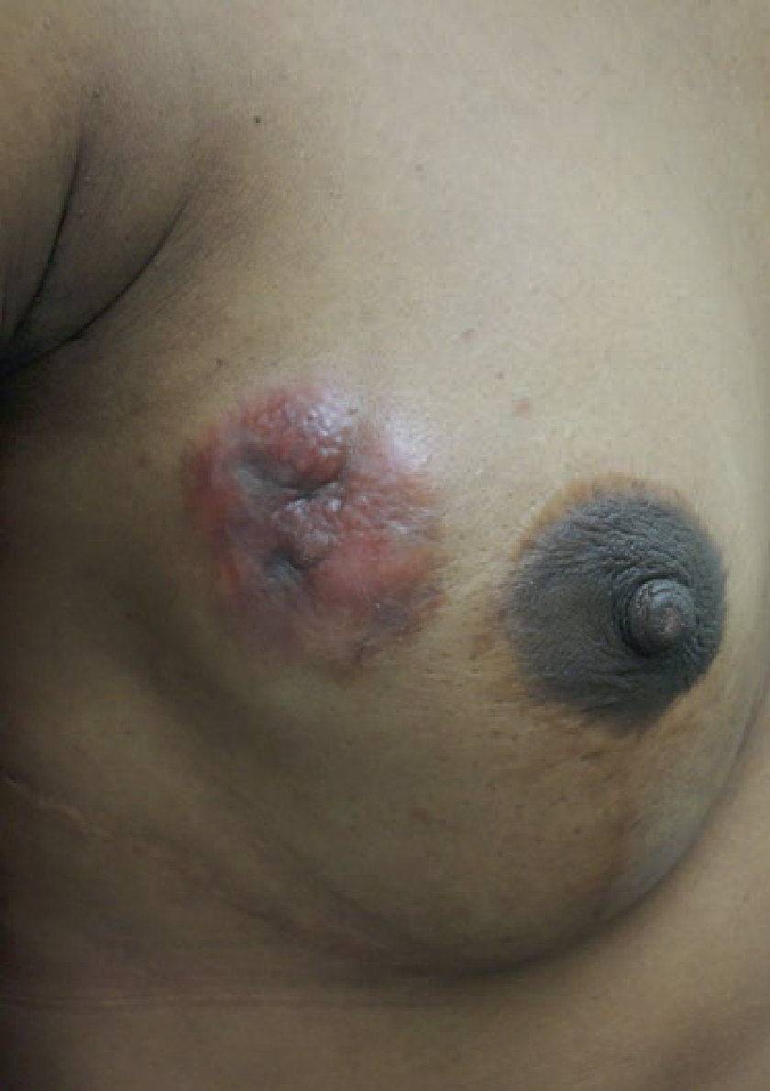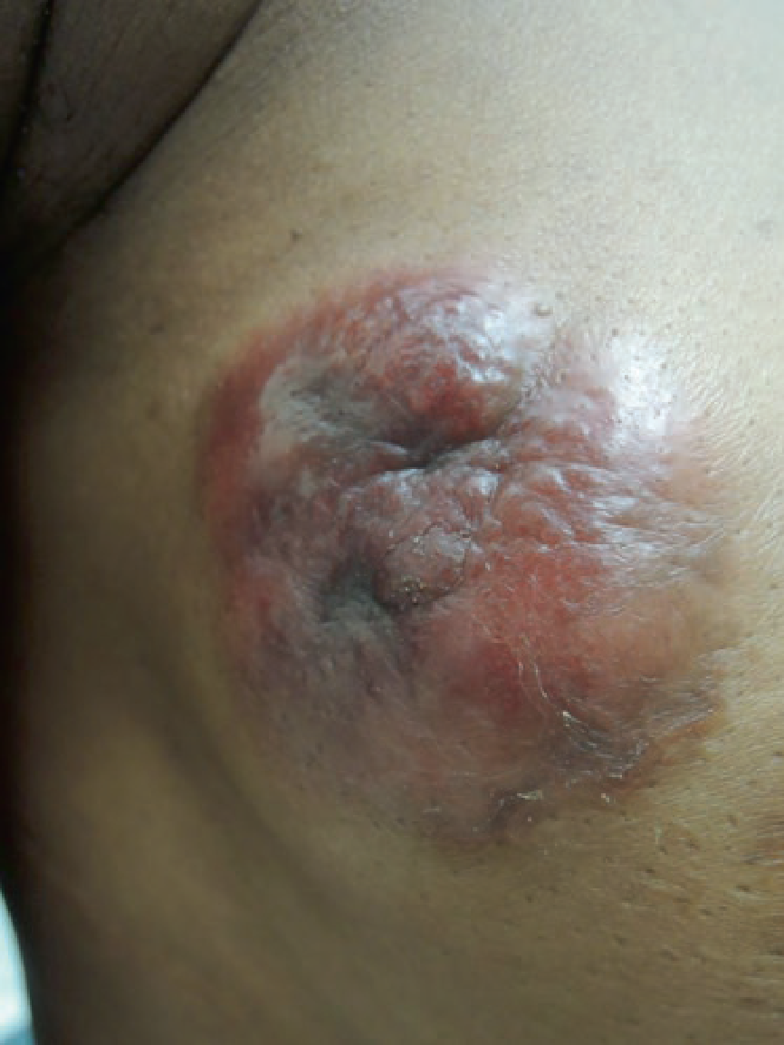

Citation: Reich D, Psomadakis CE, Buka B. Top 50 Dermatology Case Studies for Primary Care Primary Care Primary Care.

Derma5: Folliculitis
HISTORY
A 33-year-old male with no past medical history presented with itchy bumps on his legs, torso and arms, present for over 1 year. The patient reported improvement in cooler weather and almost complete resolution in winter. With humid weather, the rash returned. He noted the rash got worse immediately after showering. Over the past few weeks, he’d noticed that each morning he was waking up with more lesions on his legs. He ran, played tennis, and surfed 2–3 times per week.

PHYSICAL EXAMINATION
Vitals were normal. On exam, there were multiple 4–5mm erythematous papules, some with pustules, scattered diffusely over the bilateral anterior lower extremities, and less diffusely on the posterior lower extremities. There were scattered 4–5mm erythematous papules on the lower forearms and abdomen as well.

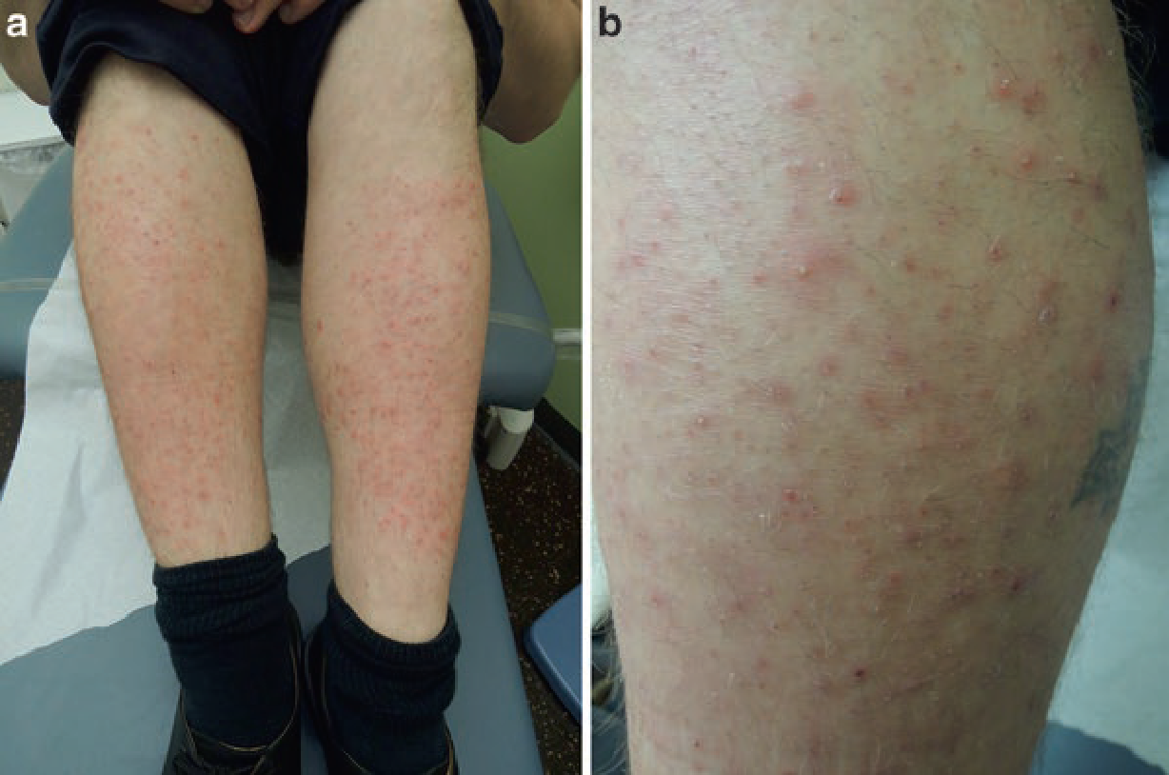

Citation: Reich D, Psomadakis CE, Buka B. Top 50 Dermatology Case Studies for Primary Care Primary Care Primary Care.
Derma6: EB Virus Infection
HISTORY
A 30-year-old man was seen in an outpatient clinic at this hospital because of fever and lymphadenopathy.The patient had been well until approximately 2 weeks before presentation, when an enlarging, tender lump developed at the posterior base of the neck on the right side. Two days before presentation, fever to a temperature of 39.4°C, a mild headache, myalgias, chills, and fatigue developed. He took ibuprofen, but his condition did not improve, and he came to this hospital for evaluation.

The patient reported no history of sore throat, coryza, or earache. He had had a low hemoglobin level in the past but was otherwise healthy. He reportedly had had a negative tuberculin skin test in the past, and he had not received an influenza vaccine during the previous year. He took no other medications and had no known allergies. He was born in India and came to the United States 4 years previously to attend school; his most recent visit to India was 6 months before presentation. He worked in an office and lived with a roommate. He was not sexually active and had no known exposures to sick contacts, animals, or blood products. He had stopped smoking 2 years before this presentation, drank alcohol occasionally, and did not use illicit drugs. His parents had diabetes mellitus; there was no family history of autoimmune or connective-tissue diseases.

PHYSICAL EXAMINATION
On examination, the temperature was 38.9°C, the blood pressure 129/80 mm Hg, and the pulse 104 beats per minute. A group of five tender lymph nodes, each approximately 1 cm in diameter, was present in the posteroinferior cervical chain on the right side; the lymph nodes in the posterior cervical chain on the left side and in both inguinal regions were nontender, and there were no abnormal lymph nodes in the supraclavicular or axillary regions. A systolic ejection murmur (grade 1 out of 6) was heard at the cardiac base; the remainder of the examination was normal. During evaluation, the temperature rose to 39.5°C and was associated with chills. Blood levels of glucose, total protein, albumin, and globulin were normal, as were results of tests of liver and renal function; testing for heterophile antibodies and rapid tests for streptococcal pharyngitis and influenza virus were negative.
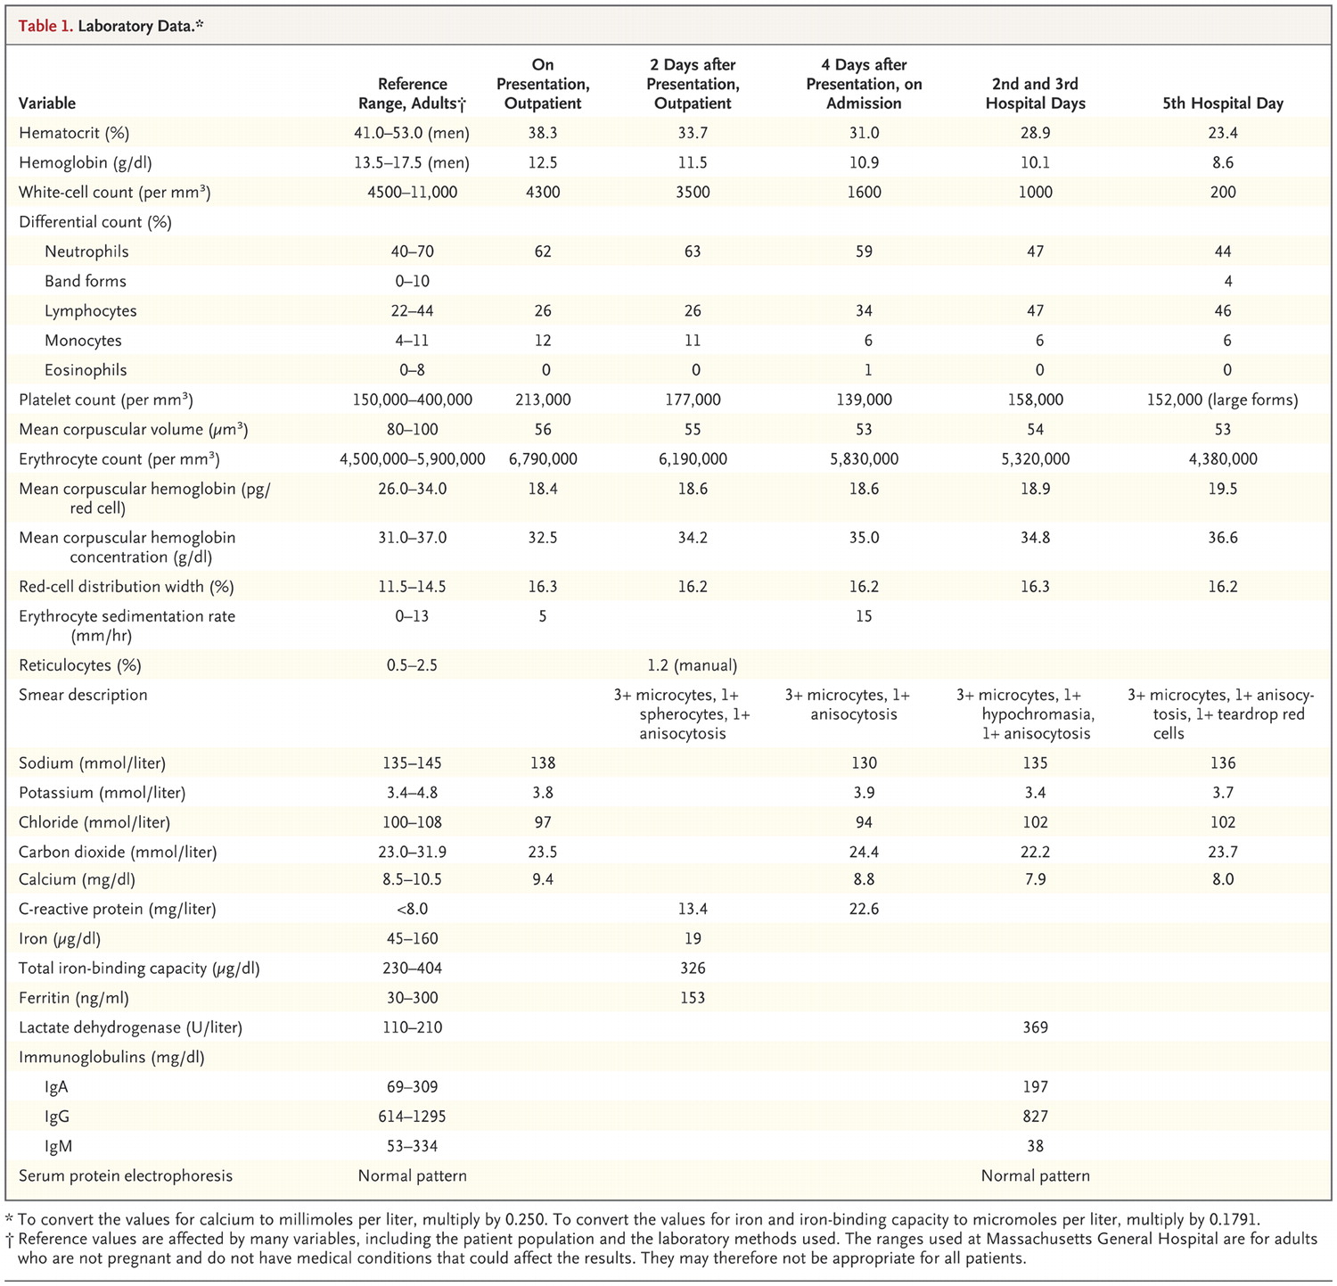
Citation: Reich D, Psomadakis CE, Buka B. Top 50 Dermatology Case Studies for Primary Care Primary Care Primary Care.

Derma7: Burns
HISTORY
A 39-year-old female presented with burns to her foot, ankle, and forearm. Five days prior, she had been carrying a pot of boiling water when it slipped out of her hand and scalded her left foot and her left forearm. Immediately after the incident, the skin of the left foot and ankle blistered. She had been putting Neosporin on the burns, wrapping them in gauze, and wearing her clogs to continue working as a professional cook. She had been taking 400–600 mg ibuprofen every 6 h as needed for the pain. She came in to be seen because the pain was becoming intolerable.

PHYSICAL EXAMINATION
Vitals were normal. On exam, the left dorsal aspect of her left foot and toes had a 12 cm × 17 cm erythematous base with an overlying intact roof from burst bullae (with no remaining fluid inside). The left medial heel area had a 4 cm × 6 cm erythematous base with intact bullae, and the left forearm had an 11 cm × 7 cm erythematous macular area, with no blisters or bullae.

Citation: Reich D, Psomadakis CE, Buka B. Top 50 Dermatology Case Studies for Primary Care Primary Care Primary Care.

Derma8: Psoriasis
HISTORY
A 47-year-old male with past medical history of asthma and psoriasis presented with a psoriatic flare. The patient had been without health insurance until recently and this visit was his first time seeing a doctor in years. He had been able to control his flares by soaking in water and Epsom salts, and occasionally using a cream.

PHYSICAL EXAMINATION
Vitals were normal. On exam, there were large erythematous scaly plaques on extensor surfaces of the bilateral forearms, bilateral lower legs, and bilateral dorsal hands, as well as on his buttocks and bilateral medial thighs.

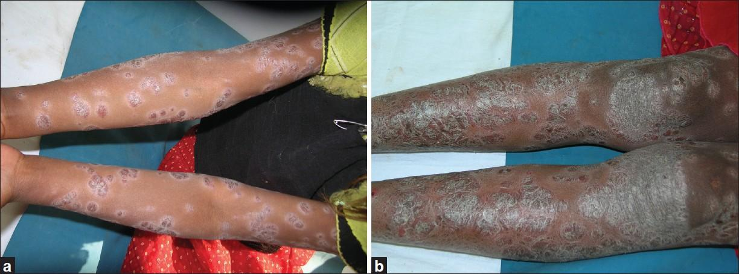
Citation: Reich D, Psomadakis CE, Buka B. Top 50 Dermatology Case Studies for Primary Care Primary Care Primary Care.

Derma9: Drug Reaction
HISTORY
A 44-year-old male with no past medical history presented with a rash on his face, chest, back, arms, and legs. One day prior, he had noticed the rash upon waking. It had started on his face and progressively spread down his trunk, and then to his arms and legs. It was not itchy. The day prior was the final day of a 7-day course of amoxicillin (prescribed by a different doctor), which the patient had taken for a tick bite. The patient had no known drug allergies.

PHYSICAL EXAMINATION
Vitals were normal. On exam, there was a diffuse, erythematous morbilliform rash on bilateral arms, bilateral legs, chest, abdomen and back. The rash spared the palms and soles. His face was erythematous but did not have the rash.
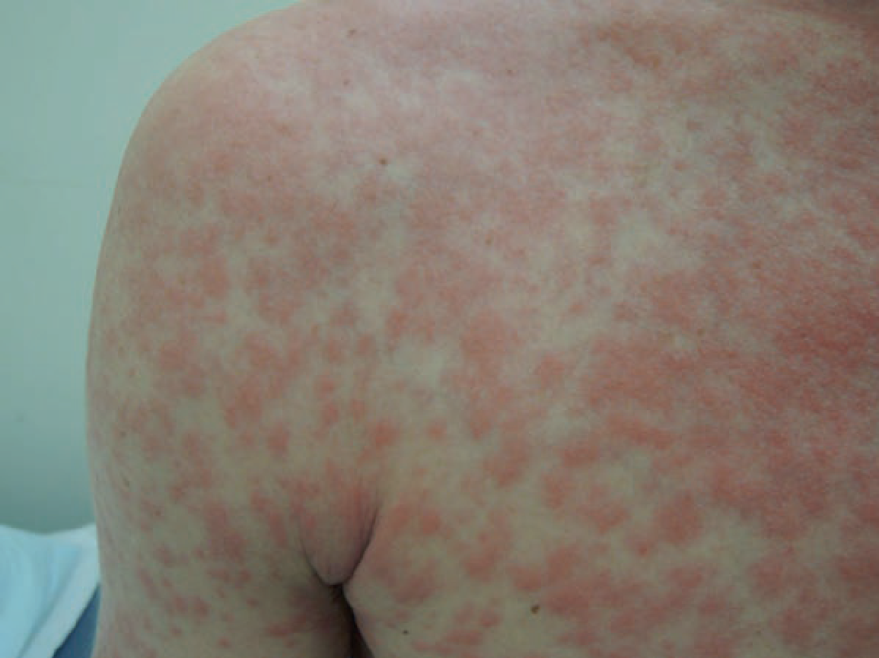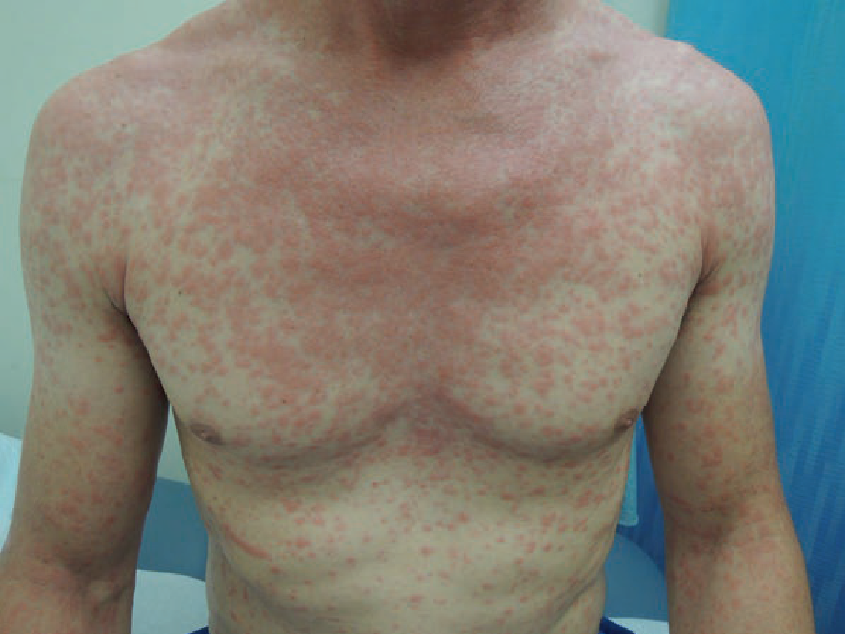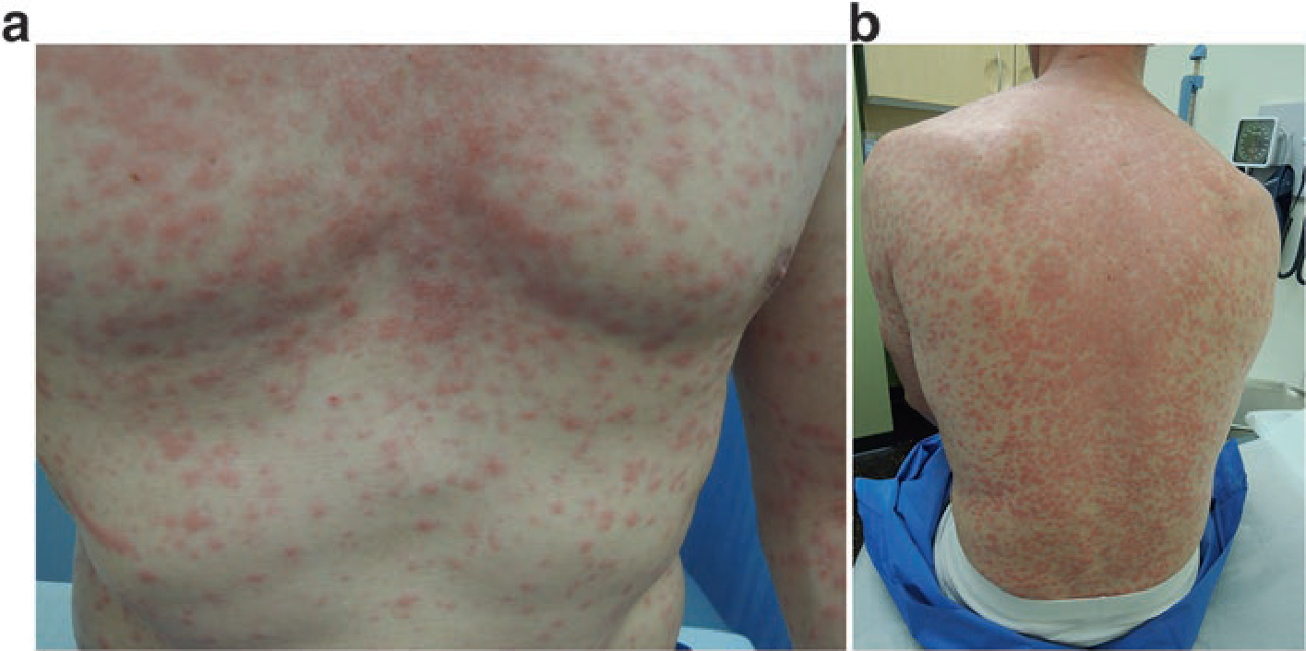
Citation: Reich D, Psomadakis CE, Buka B. Top 50 Dermatology Case Studies for Primary Care Primary Care Primary Care.

Derma10: Shingles
HISTORY
A 29-year-old male with no past medical history presented with bumps on his fore-head, behind his left ear, and near his left eye. One week prior, the patient was accidentally hit on his left forehead by a car door while getting in. The next day, he woke up with a bump on his left frontal forehead area where he had been hit. The following day, he noticed a bump behind his left ear. Two days after that, his left medial eye area started to become red and then developed bumps. While his fore-head was itchy, none of the other bumps or associated areas were painful. He was
afebrile and felt well. He reported having chickenpox as a child. He had tried mois
-turizer and ice on the lesions; however, neither helped.

PHYSICAL EXAMINATION
Vitals were normal. On exam, on his left superolateral frontal scalp, there was a 3.2cm× 2 cm area of macular erythema with one fluid-filled vesicle inferiorly. This was non-tender to palpation. Lateral to the left superior aspect of his nose and medial to his left eye, there was a 1cm× 0.5cm erythematous macule containing 2 small (1 mm) papules centrally. The left infraorbital area featured edema and erythema. Tender, enlarged lymph nodes were noted at the left occipital and left posterior auricular areas.

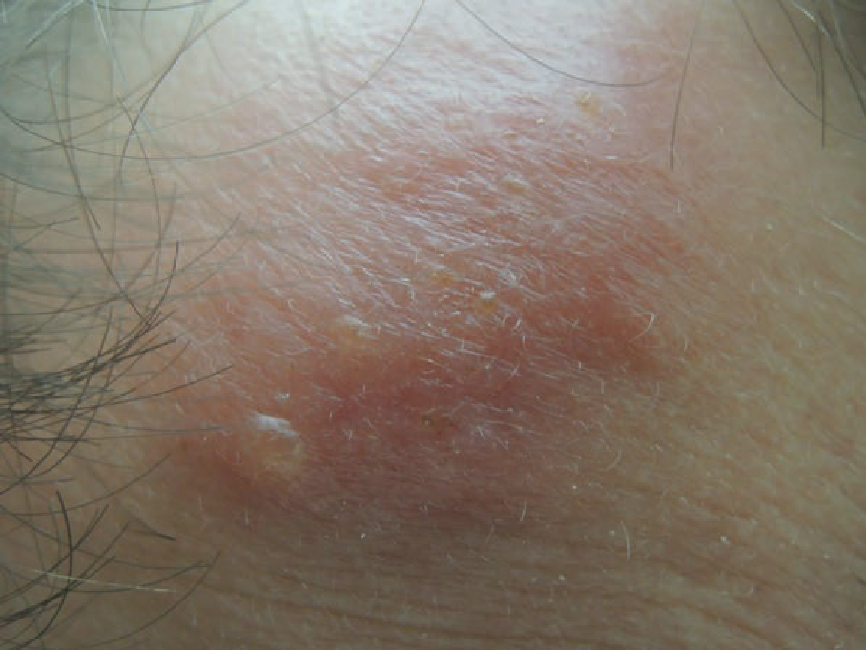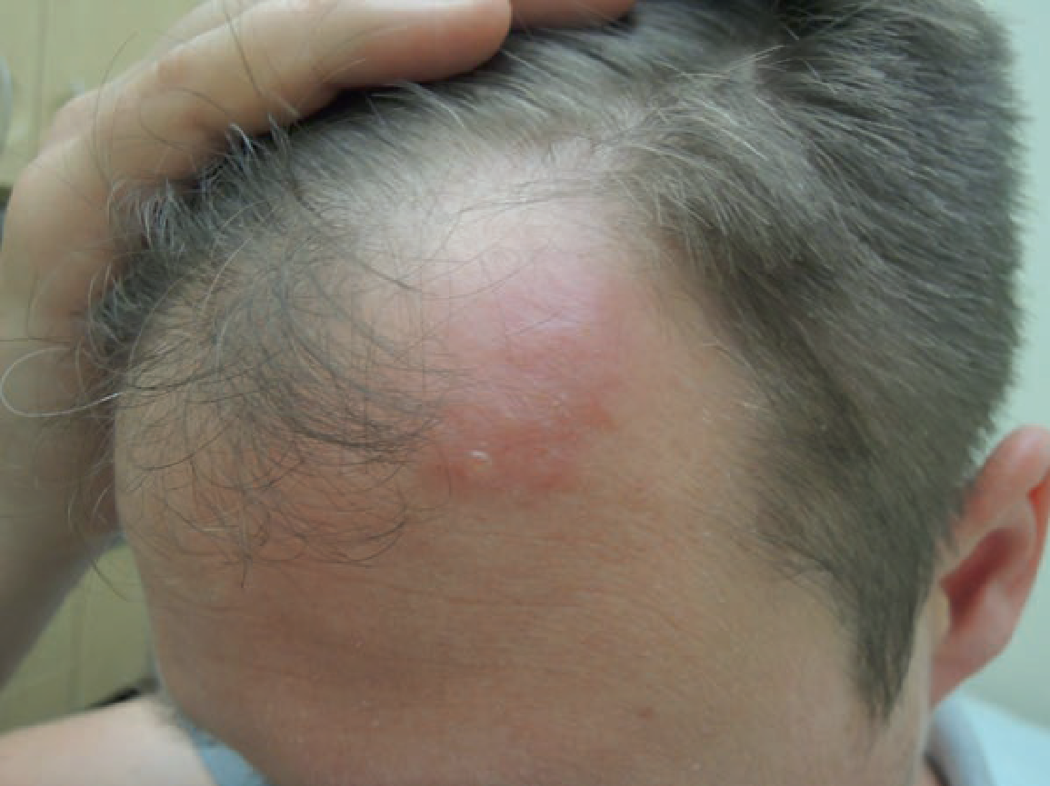
Citation: Reich D, Psomadakis CE, Buka B. Top 50 Dermatology Case Studies for Primary Care Primary Care Primary Care.

Derma11: Nevi
HISTORY
A 47-year-old female presented with a mole on her right cheek. Per patient, this mole had been present throughout her life. Until 5 years prior, the mole had been more uniformly dark brown in color. In the past 5 years, the patient noted that the coloring was more varied, with the center remaining darker colored but the periphery becoming lighter. The mole grew a single black hair out of its center, which she regularly plucked.

PHYSICAL EXAMINATION
Vitals were normal. On exam, there was a 0.5 cm brown, raised, round nevus with central dark brown pigmentation and surrounding lighter brown coloring. The borders were regular. There was a single dark-colored hair growing from the center of the nevus as well as several lighter colored hairs.
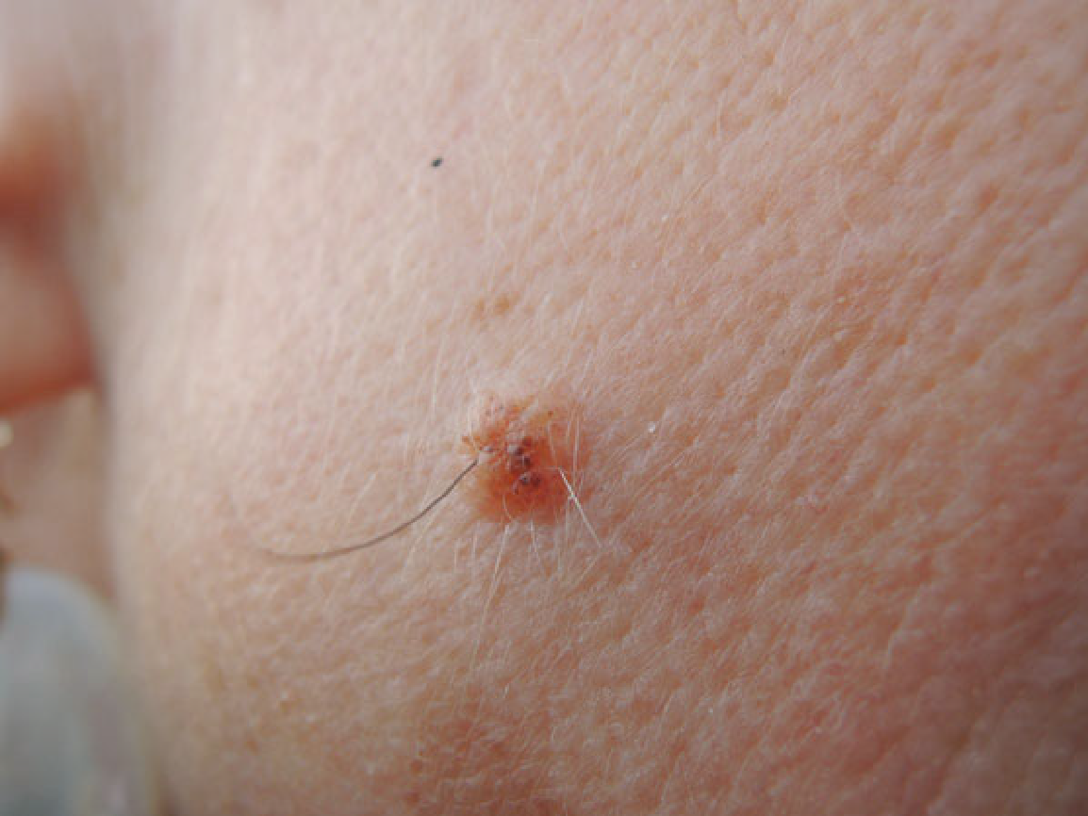
Citation: Reich D, Psomadakis CE, Buka B. Top 50 Dermatology Case Studies for Primary Care Primary Care Primary Care.

Derma12: Candidiasis (Fungal Infection)
HISTORY
A 17 year old male with no past medical history presented with a rash on his left hand that he had for a month prior to this visit. He had been applying Vaseline to it, which seemed to help. It was occasionally itchy, and he felt it had started to affect the fingernail on his fourth finger. The rash was only on his hand and nowhere else on his body.

PHYSICAL EXAMINATION
Vitals were normal. On exam, the distal portion of his left palm as well as the finger webbings of his left hand had an erythematous macular rash. The dorsal aspect of his left hand had a round erythematous, slightly scaly macular rash extending from the finger webbing between the second and third fingers to the proximal aspects of both fingers. This rash had a slightly darker erythematous border with slight central clearing.

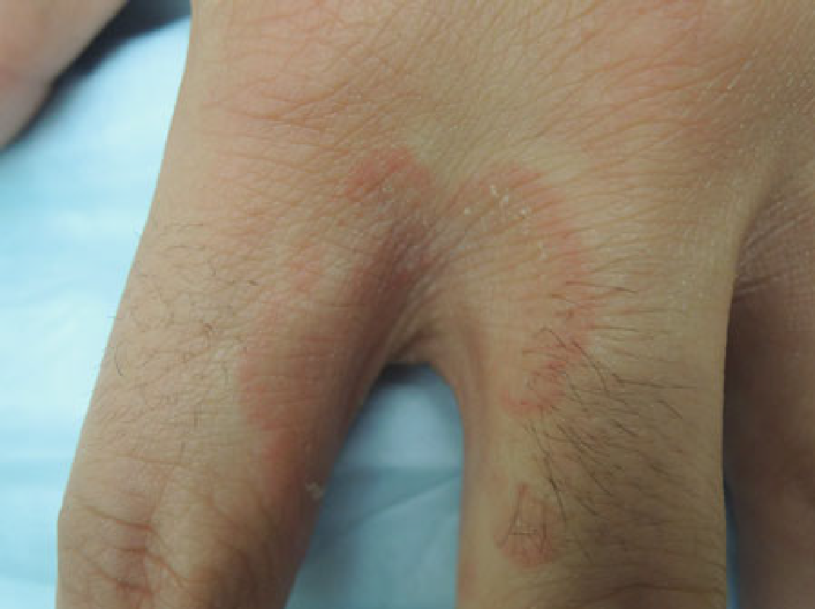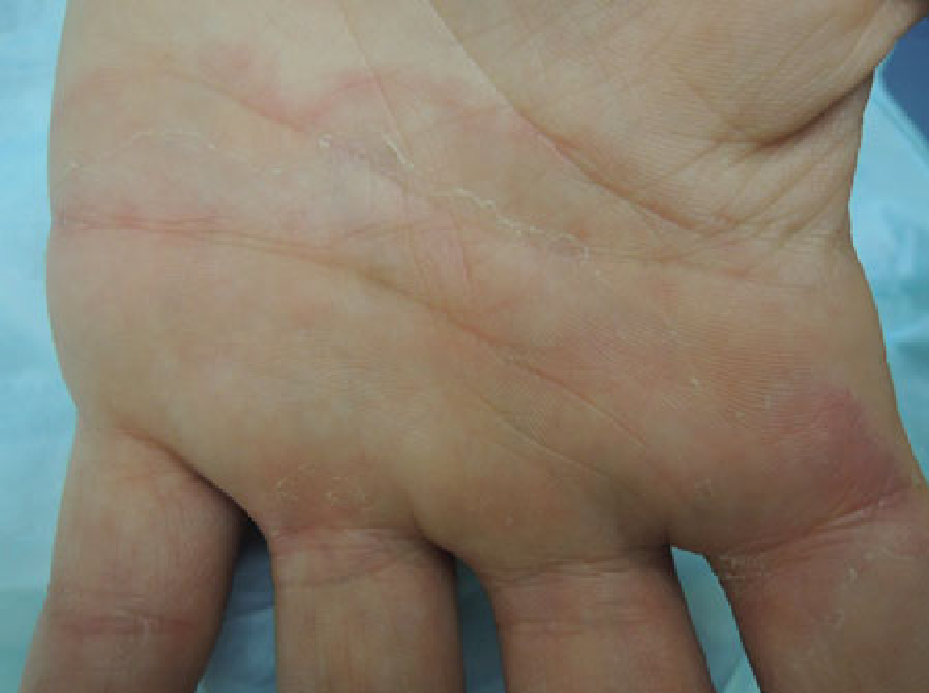

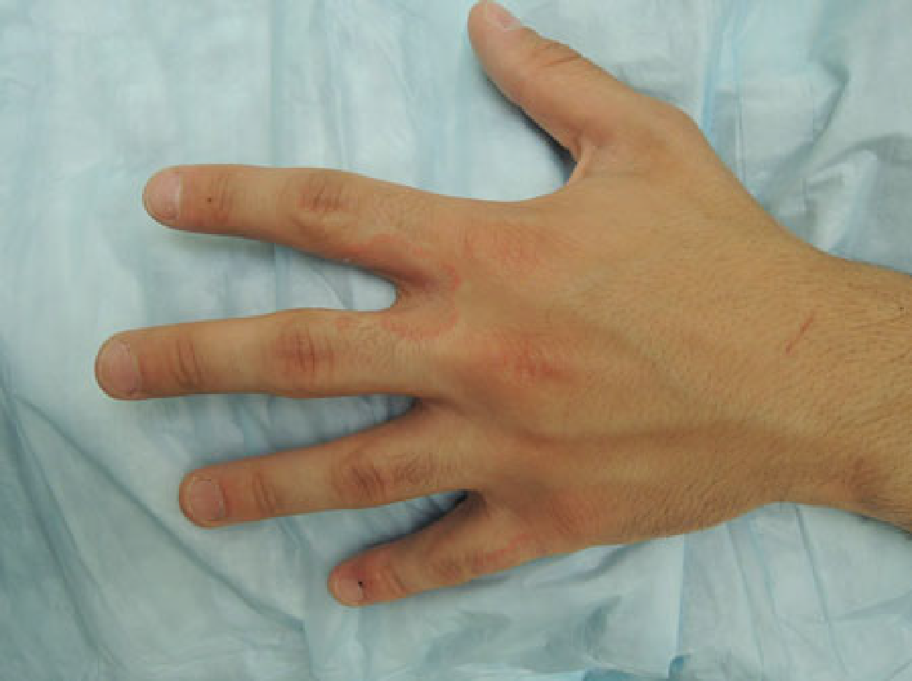

Citation: Reich D, Psomadakis CE, Buka B. Top 50 Dermatology Case Studies for Primary Care Primary Care Primary Care.

Derma 13: Squamous Cell Carcinoma

HISTORY
A 65 year old African-American female presents with a 1 year history of a scar on her lower leg that has been increasing in size. It is nontender, but occasionally pruritic and bleeds often. She grew up in Wisconsin and on further questioning, reported frequent use of well water.

PHYSICAL EXAMINATION
On exam, there is a 2 cm erythematous to violaceous, round, thin plaque on the left lower leg. There are shallow ulcers in the center of the plaque
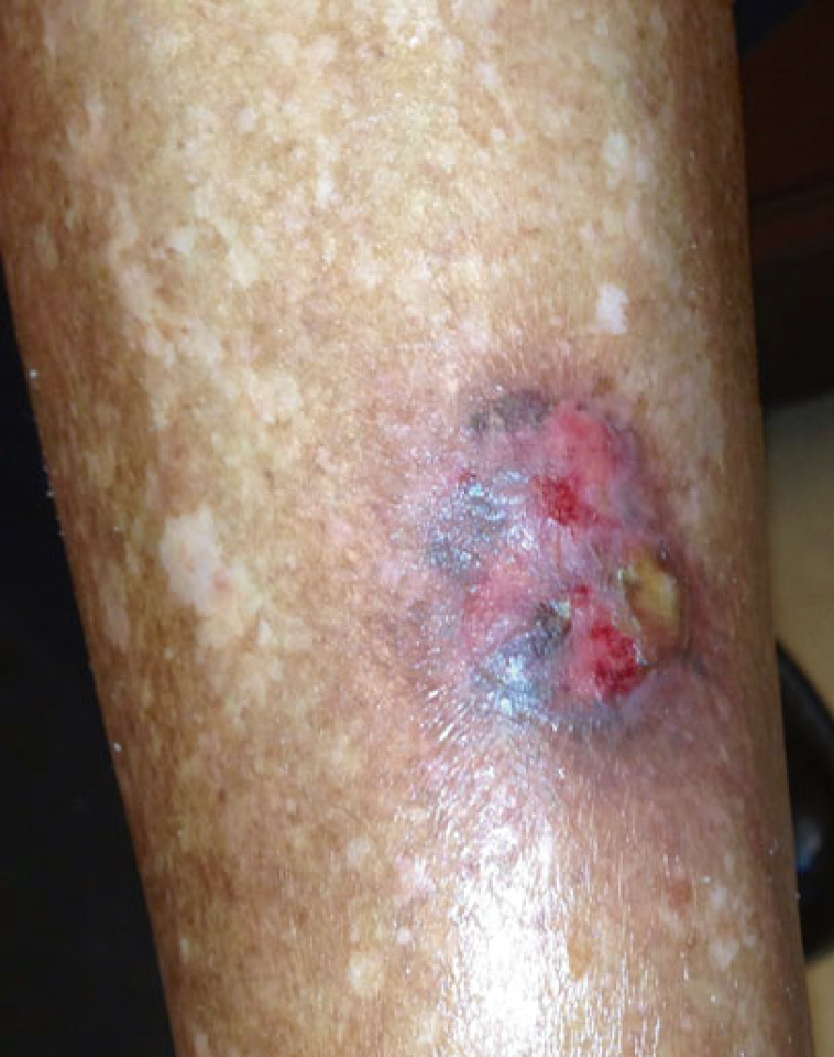

SCC in African American with arsenic exposure. There is a 2 cm erythematous and violaceous, round, thin plaque on the left lower leg. There are shallow ulcers in the center of the plaque

